**Tugas VRVEX Hidden Pixel Art & Encoded Message**

* **Encoded Message (Playground J)**

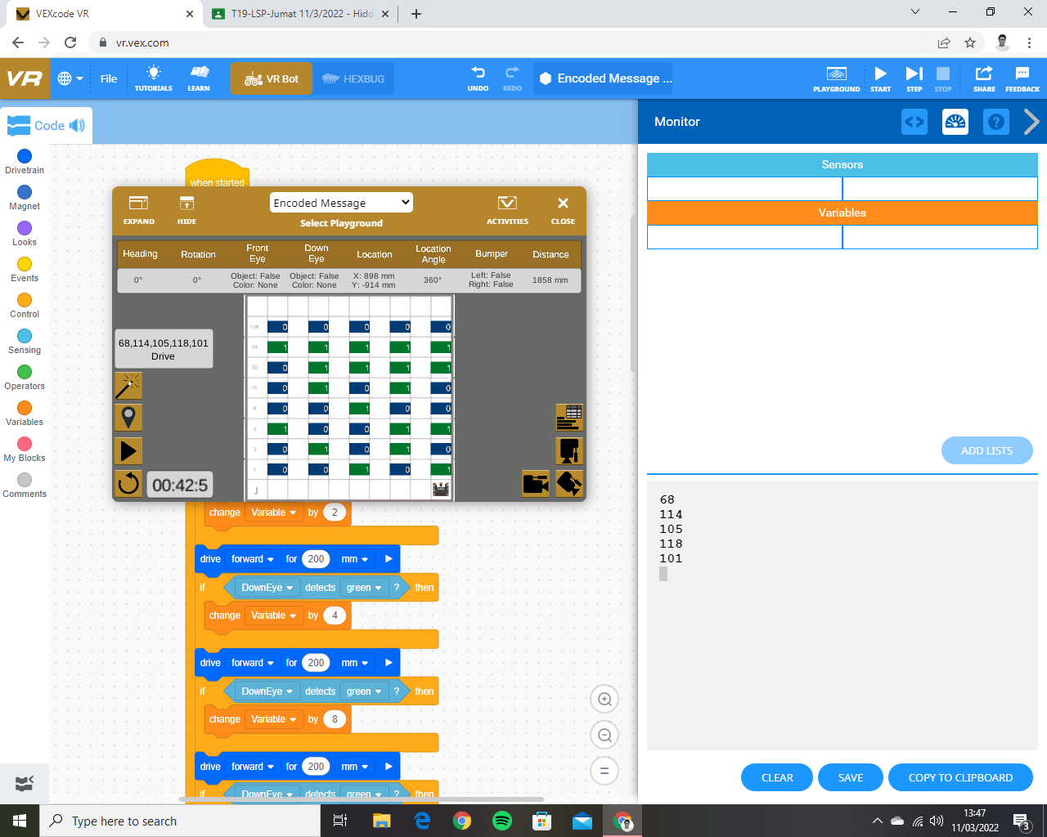

* 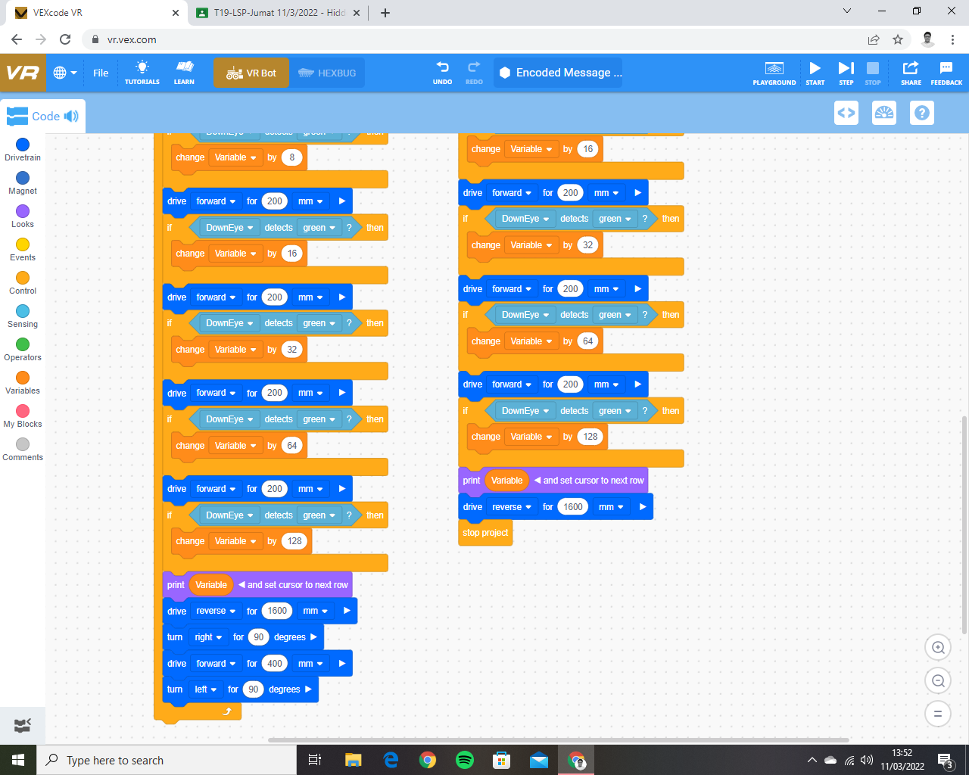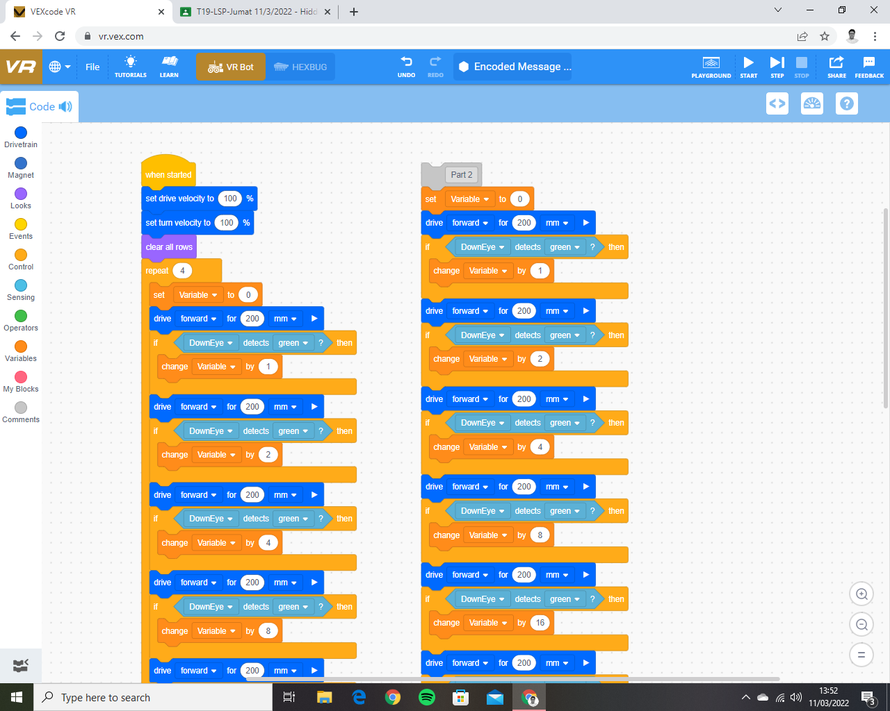**Encoded Message (Code)**
* **Hidden Pixel Art (Code + Playground J)**

